# NATIONAL COMMUNICATIONS AUTHORITY (NCA), GHANA

**Digital Video Broadcasting Authorisation**

**NCA FORM AP03C**

## Application Fee Receipt No:

*(Please attach Receipt)*

## Date:

*(Submission Date)*

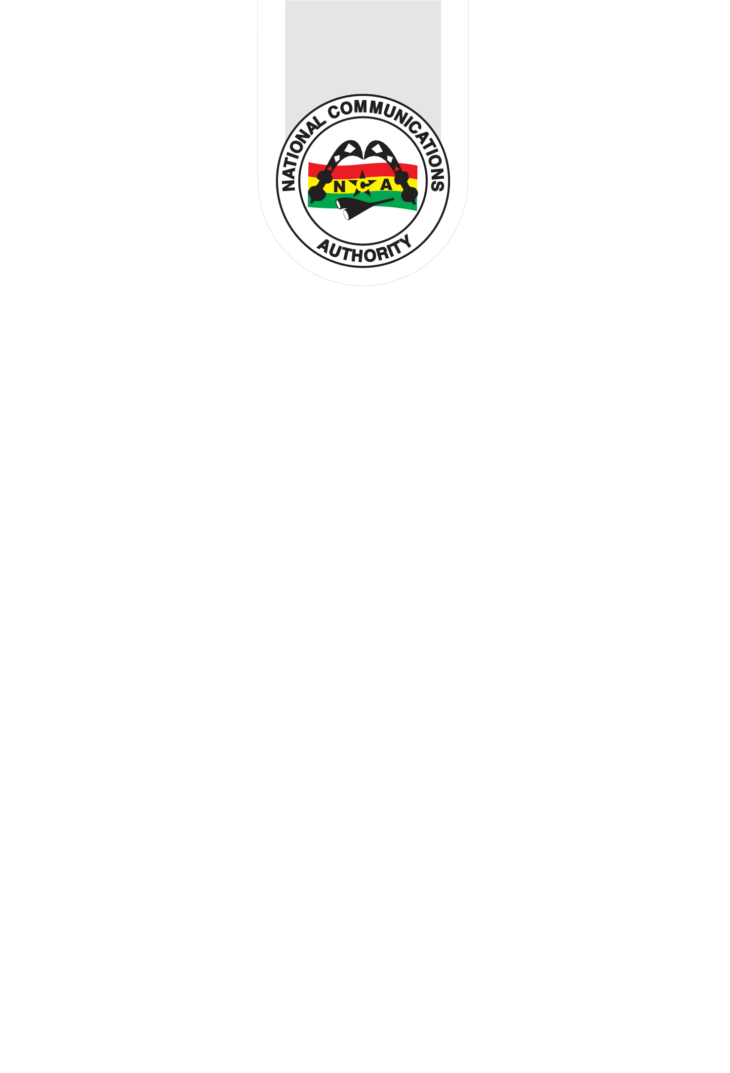

Application Checklist. Tick (x) in box

* A completed application form
* Cover Letter
* Any other Supporting Documents – Please list
* Please refer to Section 8 for required documents

# Application Form for Digital Video Broadcasting Authorisation

|  |  |  |  |  |
| --- | --- | --- | --- | --- |
| **Type Of Application** | | | | |
|  | | | | |
| New |  |  |  | |
| Renew |  | - | In case of New license application, please fill all sections below except section 8. | |
| Modify |  | - | In case of Modifying a license, please fill the license number and the sections to be modified. | |
| Cancel |  | - | In case of Renew or Cancel please fill all sections below. | |
| License Number:  (In case of Modifying a license) | | | | |
| Digital Video Broadcasting Service   1. Digital Terrestrial Pay Television (Service only) 2. Digital Terrestrial Pay Television (Service and Network) 3. Digital Terrestrial Television Network only 4. Digital Terrestrial Free-to-Air Television Programme Channel 5. Digital Terrestrial Radio Service on TV Multiplex 6. Satellite Television Broadcasting (Pay TV Direct-to-Home Bouquet) 7. Satellite Television Broadcasting (Free-to-Air Direct-to-Home Bouquet) 8. Satellite Television Broadcasting (Free-to Air Direct-to-Home Single Channel) 9. Digital Terrestrial Television additional Services (eg. Teletext, etc) 10. Digital Terrestrial Mobile Television Service 11. Digital Cable Television 12. Television over Internet Protocol | | | | |
| Technology *(Applies to ONLY DAB)* Single Frequency Network (SFN) Multiple Frequency Network (MFN) | | | | |
| Coverage *(Applies to ONLY (ii), (iii) & (iv) above. Coverage of the rest are classified as Nationwide)* | | | Regional Nationwide | |
| For DTT Free To Air Programme Chanel, please provide particulars of Network Operator:   1. Name: K- NET LIMITED 2. Location: KANDA | | | | |
| Regions *(Applies to ONLY Regional Coverage)* | | | | Greater Accra Region Eastern Region  Ashanti Region Central Region  Western Region Western North Region  Bono Region Bono East Region  Ahafo Region Volta Region  Oti Region Savanna Region  Northern Region North East Region  Upper East Region Upper West Region |

NCA FORM AP03C -- 2

|  |  |
| --- | --- |
| **1.0 Administrative Information** (to be filled by Applicant) | |
| Licensee/Applicant Name | A PLUS MEDIA |
| User ID  (Fill “Applicant Identification form”, in case you are a new applicant or you do not have your User ID) / |  |
| Authorized Person | ASARE OBENG |
| Technical Contact | ASARE OBENG |
|  | |



|  |  |  |
| --- | --- | --- |
| **2.0 Geographical information** | | |
| 2.1 | Location | ACCRA |
| 2.2 | Station Address | GT-785-5829, HOUSE NUMBER AC 13, NEAR KFC, COMMUNITY 15, SPINTEX ROAD |
| 2.3 | Longitude* |  |
| 2.4 | Latitude * |  |

|  |  |  |  |  |  |
| --- | --- | --- | --- | --- | --- |
| **3.0 Station Specific Technical Informationn** | | | | | |
| 3.1 | Modulation Type * | QPSK | 16-QAM |  | 64-QAM |
| 3.2 | Code Rate * | 1/2 | 2/3 3/4 | 5/6 | 7/8 |
| 3.3 | Reception Mode * | Fixed Mobile | Portable outdoor |  | Portable indoor |
| 3.4 | Type of Spectrum Mask * | Non-Critical | Sensitive |  |  |
| 3.5 | Effective Radiated power (W) * |  | | | |
| 3.6 | Antenna height AGL (m) * |  | | | |

|  |  |  |
| --- | --- | --- |
| **4.0 Equipment Details** | | |
| 4.1 | Manufacturer of Transmitter * |  |
| 4.2 | Model of Transmitter * |  |
| 4.3 | Manufacturer of Filter * |  |
| 4.4 | Model of Filter * |  |

|  |  |  |
| --- | --- | --- |
| **5.0 Antenna details** | | |
| 5.1 | Manufacturer * |  |
| 5.2 | Model * |  |

NCA FORM AP03C -- 3

|  |  |  |
| --- | --- | --- |
| 5.3 | Antenna gain (dBi) * |  |
| 5.4 | Polarization | H - Horizontal M - Mixed V – Vertical |
| 5.5A | Directivity | Omni Directional |
| 5.5B | In case of directional Antenna, Please fill the Antenna Radiation Pattern details below or provide a soft copy of the antenna pattern txt file | |



|  |  |  |  |
| --- | --- | --- | --- |
| **6.0 Implementation Plan** | | | |
|  |  | Start Date | End Date |
| 6.1 | Site Acquisition for studio and transmission system | 1/03/25 | 30/03/25 |
| 6.2 | Procurement of Equipment for studio and transmission system | 1/04/25 | 31/04/25 |
| 6.3 | Installation of Equipment for studio and transmission system | 1/05/25 | 31/05/25 |
| 6.4 | Engineering Test * | 1/06/25 | 31/06/25 |
| 6.5 | Invitation for Inspection | 1/07/25 | 28/07/25 |

NCA FORM AP03C -- 4

|  |  |  |
| --- | --- | --- |
| **7.0 License(s) List**  (fill only in case of Renew or Cancel) | | |
| # | 7.1 | 7.2 |
|  | License Number | Date of Expiry |
|  |  | / / |
|  |  | / / |
|  |  | / / |
|  |  | / / |
|  |  | / / |
|  |  | / / |
|  |  | / / |
|  |  | / / |
|  |  | / / |
|  |  | / / |
|  |  | / / |
|  |  | / / |

|  |  |
| --- | --- |
| **8.0 Attached Documents** (to be attached by Applicant) | |
| Document Name | Check if attached |
| Evidence of the Financial Resource to establish the station (First time applicant only) |  |
| Five (5) years Audited Financials Statement (Renewal application only) |  |
| Evidence of community support (Applicable to community radio applicant) |  |
| Tax Clearance Certificate (Renewal only) |  |
| SSNIT Clearance Certificate (Renewal only) |  |
| Any Other Relevant Document(s) |  |

**9. Undertaking:**

I/We …**A PLUS MEDIA**… hereby certify that the information supplied in this application form is true in all respects and I/We hereby give undertaking that upon grant of the Licence/Authorisation, I/We shall abide by the terms and conditions upon which the Licence/ Authorisation is granted. I/We accept that my/our Licence/ Authorisation may be revoked and the appropriate penalty/ penalties applied if it is established that I/We have been granted Licence/Authorisation based on incorrect information. I/We further undertake to abide by all existing ITU Regulations and Communications laws of the country as well as other rules, regulations and directives that may be issued.

Dateof Submission: / /

dd / mm / yy Signature of Authorised Representative/Seal:

NCA FORM AP03C -- 5

|  |  |  |  |  |  |
| --- | --- | --- | --- | --- | --- |
|  | | | | | |
|  | | **10. For Administrative use Only** | |  | |
| Customer ID |  |
| Name of Employee who received the application |  |
| Dateof Applicationreceipt: / /  dd / mm / yy Signature/Seal: | |
|  | |  | |  | |
|  | NCA FORM AP03C -- 6 | | | |  |